Lab Worksheet 5
(For Lab 05, 10 points)

Instructions: Open this file in Microsoft Word and type your answers after each question. When you are finished, click “Save As”, select either .doc or .docx format, and use this as a file name:

Your last name_LabWorksheet5. For example: Marsh_LabWorksheet5.

Once you have done that, email it to me as an attachment. My email address is: jmarsh@clark.edu

Do NOT send me your files through Canvas. Send them via email.

I will not be accepting submissions in other formats such as .pdf, shared files, OneDrive files, Google Docs, etc. In order to efficiently grade your work, it needs to be submitted in a format that I can access quickly.

Answers to questions should be written out in your own words. Copying and pasting is not acceptable and will result in a score of zero. It is very easy for me to spot material that has been copied and pasted!

Observe the following videos:

- Inoculation of Agar Plate using Streak Plate Culture Technique (only watch until 4:15; note that only three sectors are used for streaking in this video)
- Beta hemolysis, Alpha hemolysis, and Gamma hemolysis on blood agar plates
- MacConkey Agar (only watch until 3:50) & Mannitol Salt Agar

Practice Preparing a Streak Plate: Virtual Lab (requires Adobe Flash Player to run)

Questions (1 point each unless stated otherwise):

- Describe a circumstance (e.g. in its’ natural environment) where Staphylococcus species bacteria might benefit from being salt tolerant.

- How might the ability to perform hemolysis benefit a hemolytic organism in its’ natural environment?

- Imagine that you have a culture containing a single bacterial species. This culture may be one of several possible species. Describe a scenario where you use Mannitol Salt agar, Blood Agar, and EMB plates to identify the unknown bacterial species. That is, how would you use these plates to help you identify it?

- What is the main goal of streaking for isolation?

- What happens if you forget to sterilize the loop in between sectors (note – it is not related to contamination)?

- What happens if you transfer from the stock culture to inoculate each of the sectors?

- Suppose you successfully streak a plate and obtain isolated colonies of two different bacterial species (that is, a mixed culture)? How can you use this plate to create a new pure culture of only one of the bacteria?

- In the table below are a variety of agar plate media available to microbiologists to cultivate bacteria. Denote whether each medium is non-selective (general growth media), selective, and/or differential by placing an “X” in the appropriate column or columns. (2 points for correctly filling out the entire table).

Type of Agar Plate | Non-selective Media | Selective Media | Differential Media
Nutrient Agar (NA)
Tryptic Soy Agar (TSA)
TSA with 5% Sheep Blood (BAP)
Chocolate Agar Plate (CAP)
MacConkey (MAC)
Eosin Methylene Blue (EMB)
Hektoen Agar (HE)
Phenyl Ethyl Alcohol (PEA)
Mannitol Salt Agar (MSA)

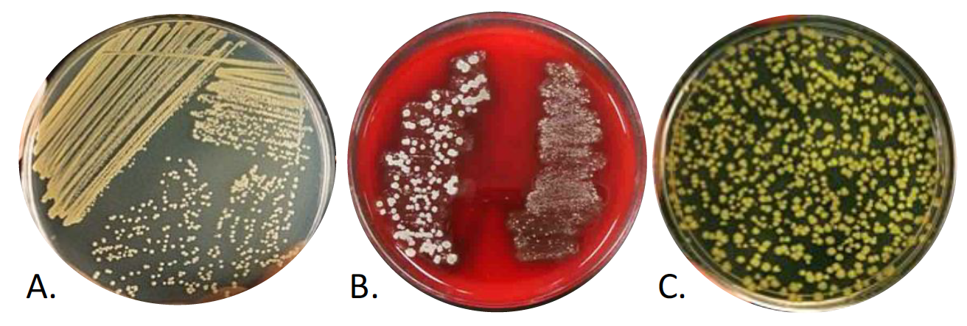
- Which agar plate below was inoculated using a streak-plate technique? (A, B or C?):

Supplemental Online Resource - Cultivation Media for Bacteria (click on “Example” for growth patterns of selected organisms and click on an agar plate to enlarge to see growth pattern).

